ALL INDIA BANK RETIREES’ FEDERATION (Regd.)
(Regn No:G 6601 under the Trade Union Act 1926)
D-1/1, Sector-C, Scheme-71,
Near Kasara Bazar School, Indore – 452 009.
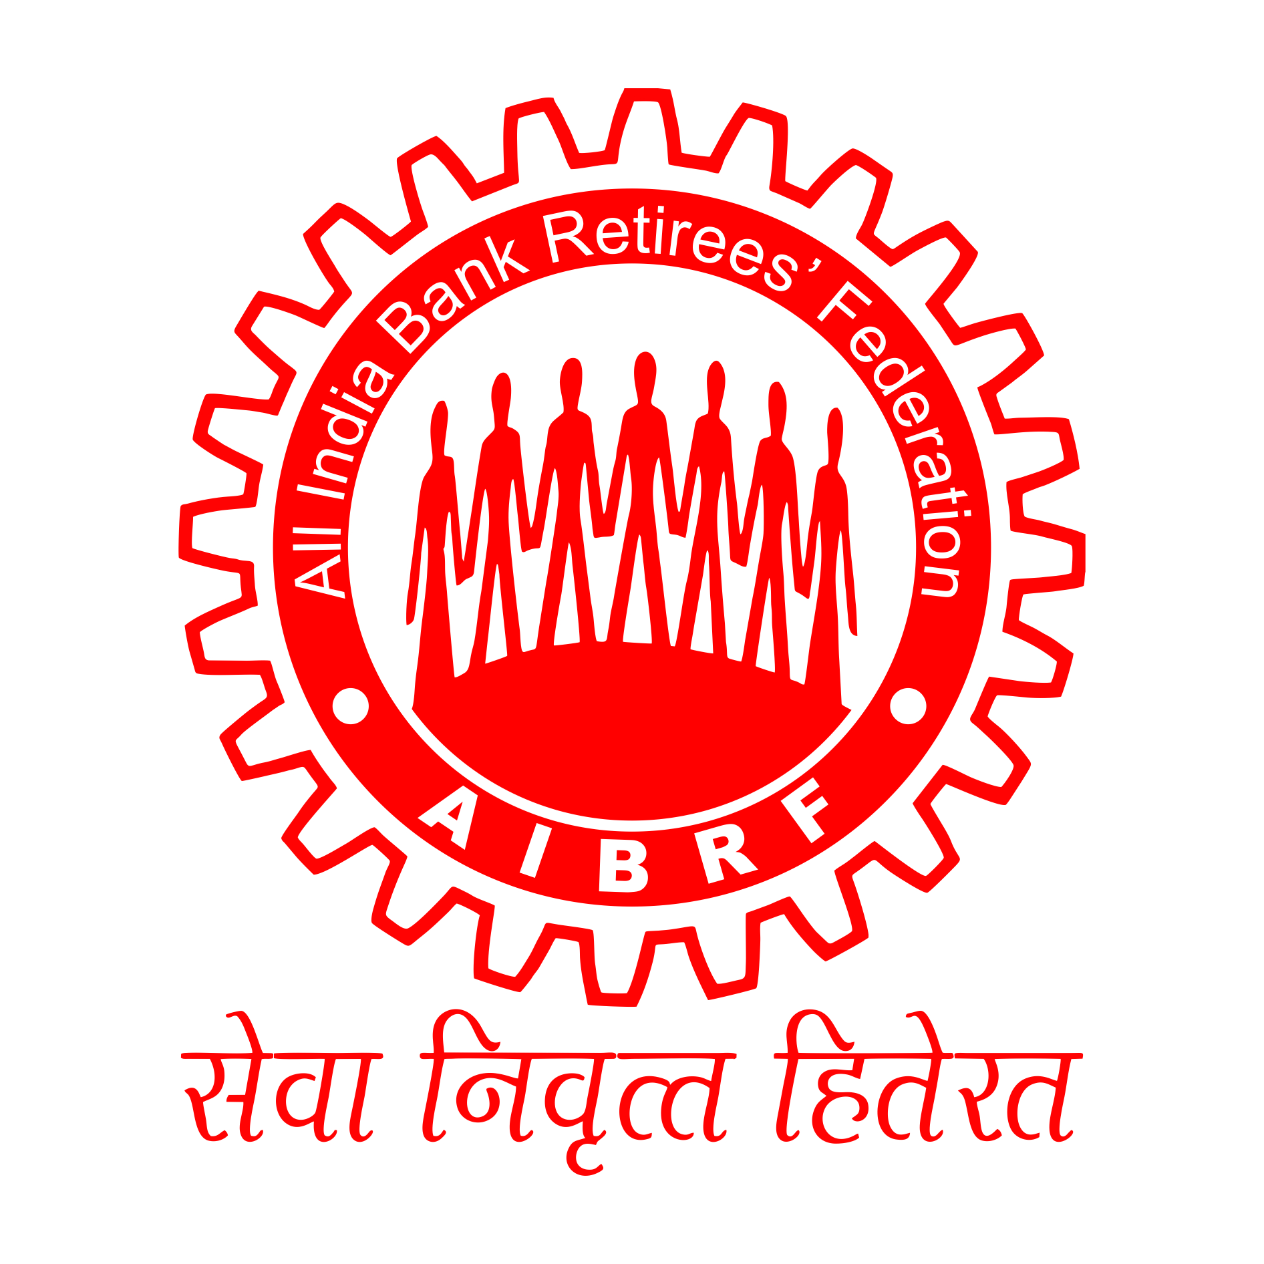
Ref:2016/490 Date:30.06.2016

The Office Bearers/ Central Committee Members/ State Body Chiefs,AIBRF.

Dear Comrades,
Re: Civil Appeal No. 8420-8421- A.B.Kasturirangan & Others V/S Canara Bank & Others- 100 Percent DA Case in Supreme Court- PROCEEDINGS ON 29.06.2016
The above two civil appeals along with 2 more civil appeals on the same subject came up our hearing in the Supreme Court on 29.06.2016.
2. Large section of bank retirees is keeping close watch on the progress of the case. We below give details in brief on the proceedings of the hearing on 29.06.2016 to enable our membership to know correct position on the progress in the case.
(a) 5 Advocates appeared on behalf of the petitioners ( Retirees) and 16 advocates appeared on behalf the Respondent ( Bank Managements & IBA )
(b)Regular hearing on these civil appeals could not take place on 29.06.2016.
(c)In the meantime, we understand Indian Bank Association has filed Intervention Application to become party in these civil appeals.
(d)The Bench has directed to list these applications along with the main matters in the month of January, 2017.
3. We find news are getting circulated in social media that the appeals will come for final disposal in the month of January, 2017. It is not correct. Similarly, it is also not factually correct that pray for interim relief was heard and was not considered by the bench. In fact no such prayer was moved.
4. AIBRF is keeping close watch on the progress of the case, in particular IBA move to join the appeals as intervener, in view of interest of large number of retirees involved. We assure the membership we shall take appropriate steps , legal and other wise from time to time to protect interest of the retirees.

MANAGEMENT COMMITTEE MEETING OF IBA ON 24,06,2016
We have vide our circular no. 2016/485 dated 25.06.2016 advised the membership that the pending matters of retirees were not in the formal agenda of the meeting to remove the confusion getting created by news in circulation in the social media.

We find that even after issuance of our above circular, news getting still widely spread among the retirees that after the meeting IBA has sent recommendations to the government for approval of 100 percent DA to pre-November 2002 retirees and improvement in family pension. According to our information which has been crossed check, no such recommendations have gone to the government from IBA after the above meeting. We are issuing this clarification to remove confusion getting created among the membership due to circulation of such news. We assure that we shall come out with our communication as soon as there are developments in the matter for which our continuous efforts are on.

With Warm Greetings,

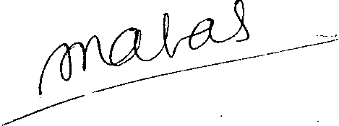
Yours Sincerely,

( S.C.JAIN )
GENERAL SECRETARY

